**MacOS Falcon Installation Instructions**  
Download the CrowdStrike Falcon installer from <https://softy.cac.washington.edu/CrowdstrikeFalcon/Mac/FalconSensorMacOS.pkg>

Open the FalconSensorMacOS.pkg on your mac to start the installer and click Continue.

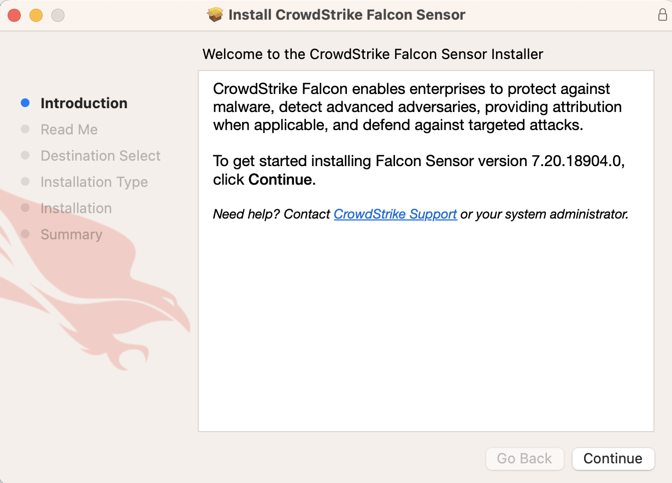  
Click Continue on the privacy and terms of use screen.

Click Install to begin the installation.

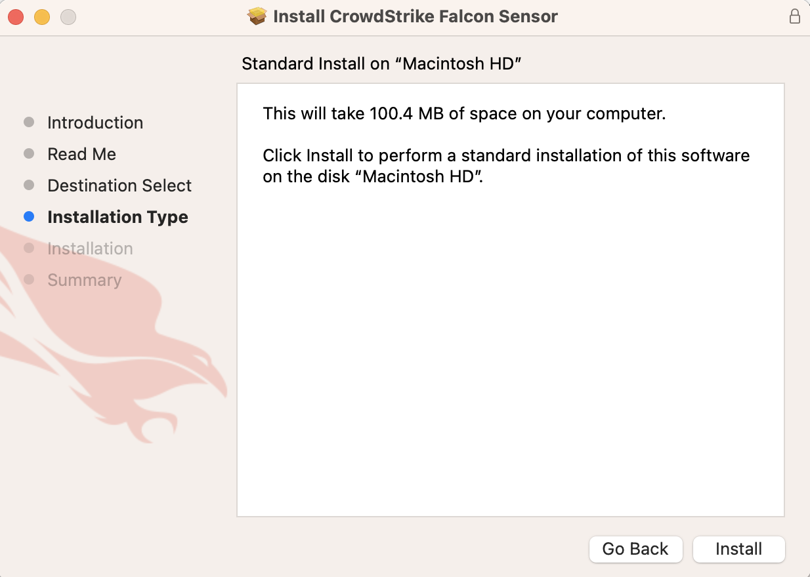

Enter your password to authorize installation.

If prompted, click OK to allow access to your Downloads folder.

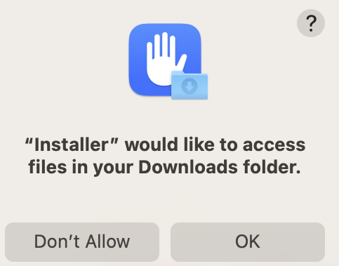

Enter: BBCF6121E8064AFAB65A27E67D945D59-DE for the Customer ID and click Continue. There is no Installation token, so leave that field blank.

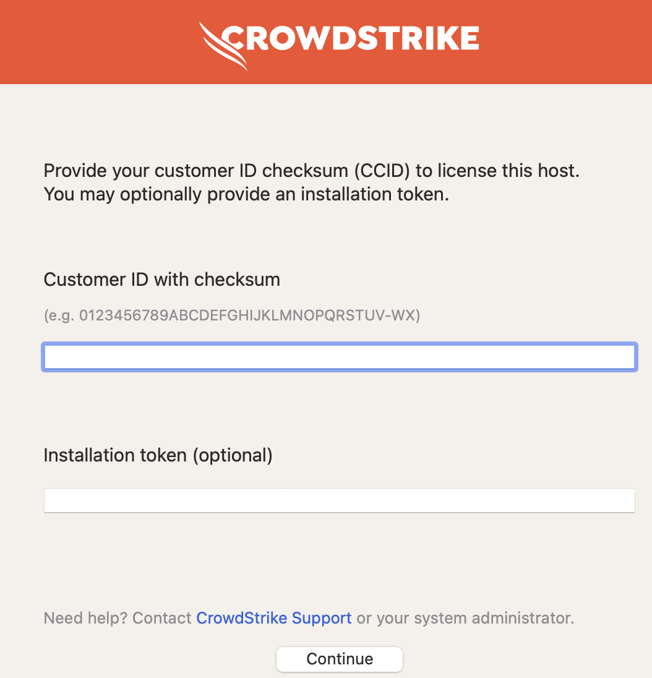

Click Setup to setup the Network filters.



Click Allow

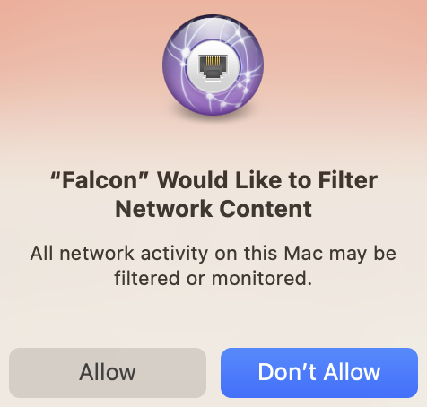

Click continue

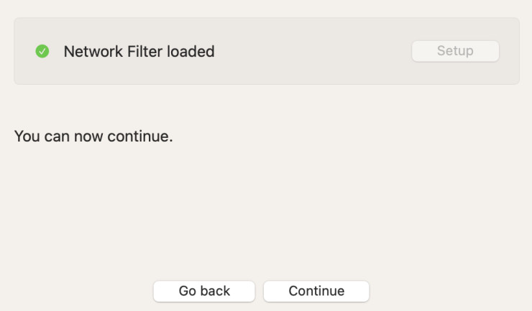

Click Setup for the Falcon extension.

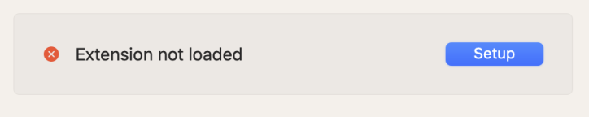

Click Ok. **NOTE:** There are 5 different Mac OS’s that are supported. This means that there will be some variability in the name and locations of extensions.

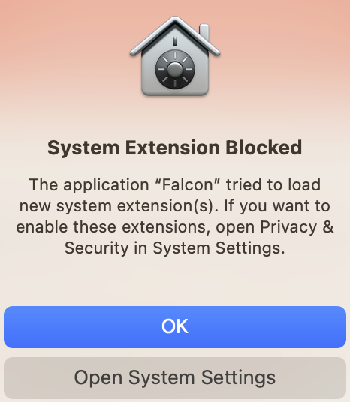

If you see a message indicating that the **system extension is still blocked**, click System Settings.



On newer Mac OS versions, you will be directed to **Login Items & Extensions**. Click the “i” to grant access for the Falcon Sensor.



On older Mac OS versions you will find this section under **Privacy & Security settings**. Scroll down and click Allow to allow Falcon to load.

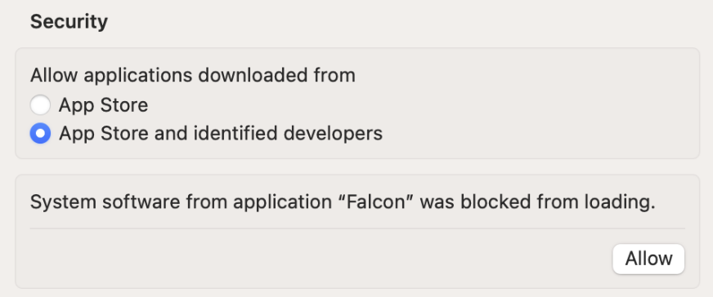

Once allowed, the Extension will indicate that it has loaded. Click Continue.



Click System Settings to grant Full Disk Access.



In your Privacy & Security settings scroll down to Full Disk Access and click on it, then click the toggle next to Falcon Sensor to grant access.

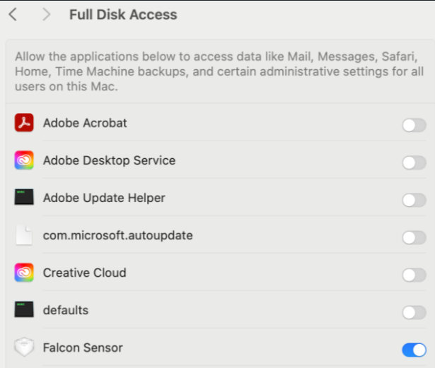

Full Disk Access will be granted. Click Continue.



You should now see a message indicating the installation was successful. Click Close and you should be almost done.

**Don’t close these directions yet**, as you need to add a group for support.

Open a Terminal on your Mac, by clicking the spotlight icon  on the menu bar and then typing in terminal. If you have problems finding terminal Apple has instructions, <https://support.apple.com/guide/terminal/open-or-quit-terminal-apd5265185d-f365-44cb-8b09-71a064a42125/mac>   
  
Once you are in the terminal paste in the following command(if you cannot copy the text in your browser then save the pdf to your computer and then copy will work):

**sudo /Applications/Falcon.app/Contents/Resources/falconctl grouping-tags set UW-IT/UW-IT**

Enter your password when prompted. The tag will be added* and you will see a message that your tag has been updated.

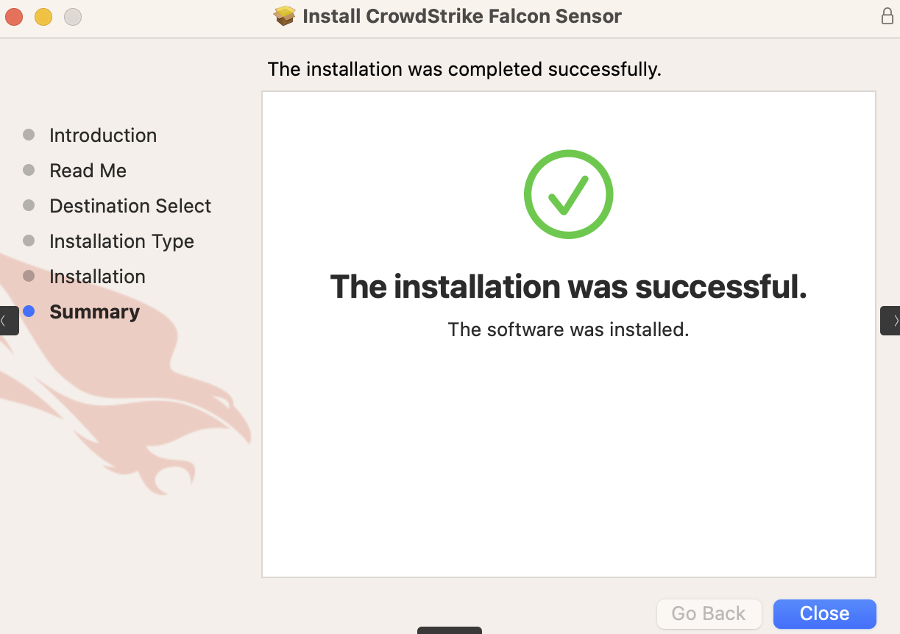

*If you are not part of UW-IT please substitute your own group tag.