Import and Export a Teams Shifts Schedule (From TeamA to TeamB)

Prerequisites:
- Create a new Microsoft Team (Referred to in this document as TeamB)
- IMPORTANT: TeamB Must have the Visibility Setting Set to “Private” (See Important Notes at bottom)
- Make sure the membership and roles match the source Team (Referred to in this document as TeamB)
- Whomever follows these instructions must be an owner in TeamA and TeamB

1). Export Schedule from TeamA:
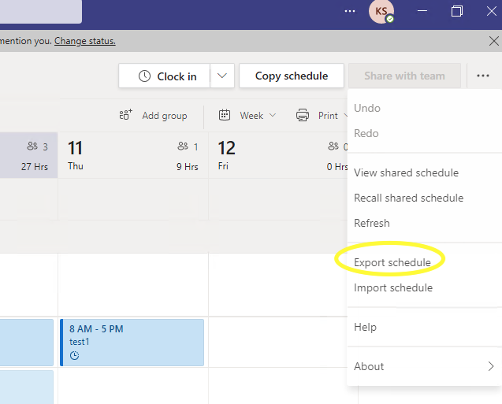

2). Make sure ‘Export in a format that can be imported’ is selected (slide button should be solid color): 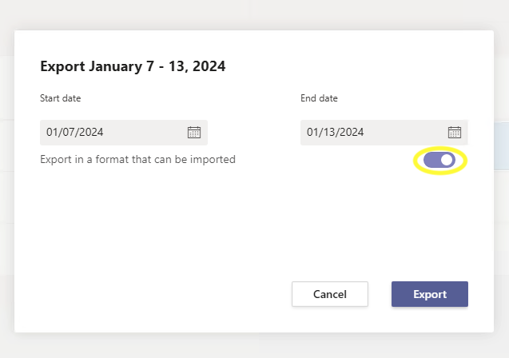

3). Verify xlsx file was downloaded successfully:
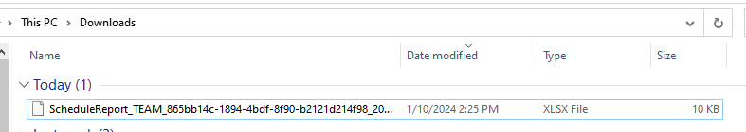

4). Now open new TeamB and verify owner/membership is identical to source TeamA. This is important as any missing members that have Shifts assignments will show up as (DELETED) in TeamB until they are added as a Teams member.

5). From TeamB, click on Shifts Icon in Teams and then click on the hamburger menu in the left corner. Scroll to the bottom schedules window and select New Schedule:
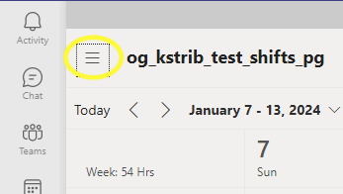


- Create New Schedule from the new TeamB (Image shows a different Team name but you will select your new Team):
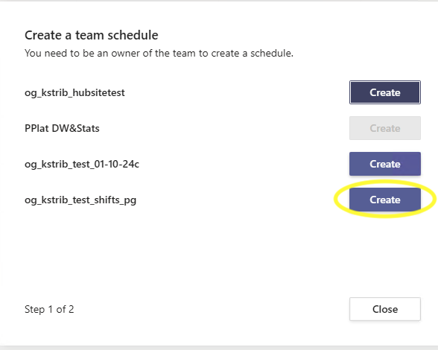

6). Remove the owner from the Unnamed Group in Shifts so no users are in the Group:
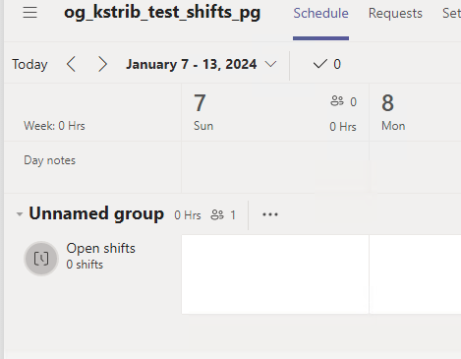

7). Select the Import option and then click the Upload File button:

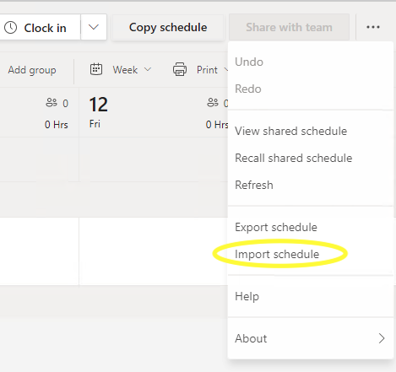

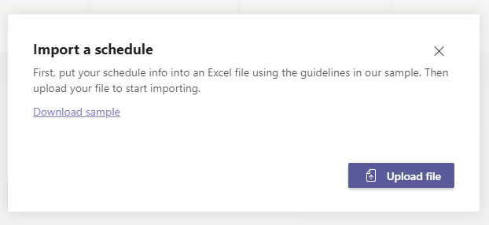

Select the xlsx file that was created in Step 2. Click Open:
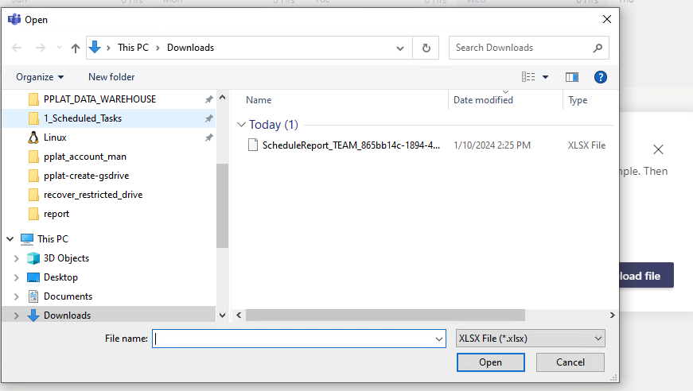

Import should complete successfully:
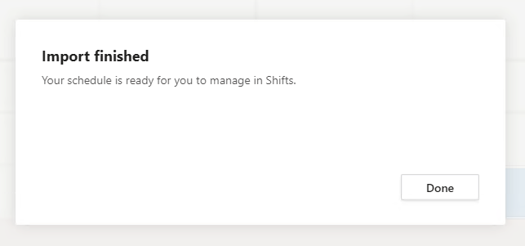

IMPORTANT NOTES:

The new TeamB must have a Visibility Setting Set to “Private”.
When you visit the Teams Provisioning form at the link below, scroll down to Membership Privacy and de-select “Secure visibility of membership list to only those in the Team”. This will set the visibility setting of the new Team to Private.

New Microsoft Team - Service Portal (service-now.com)

